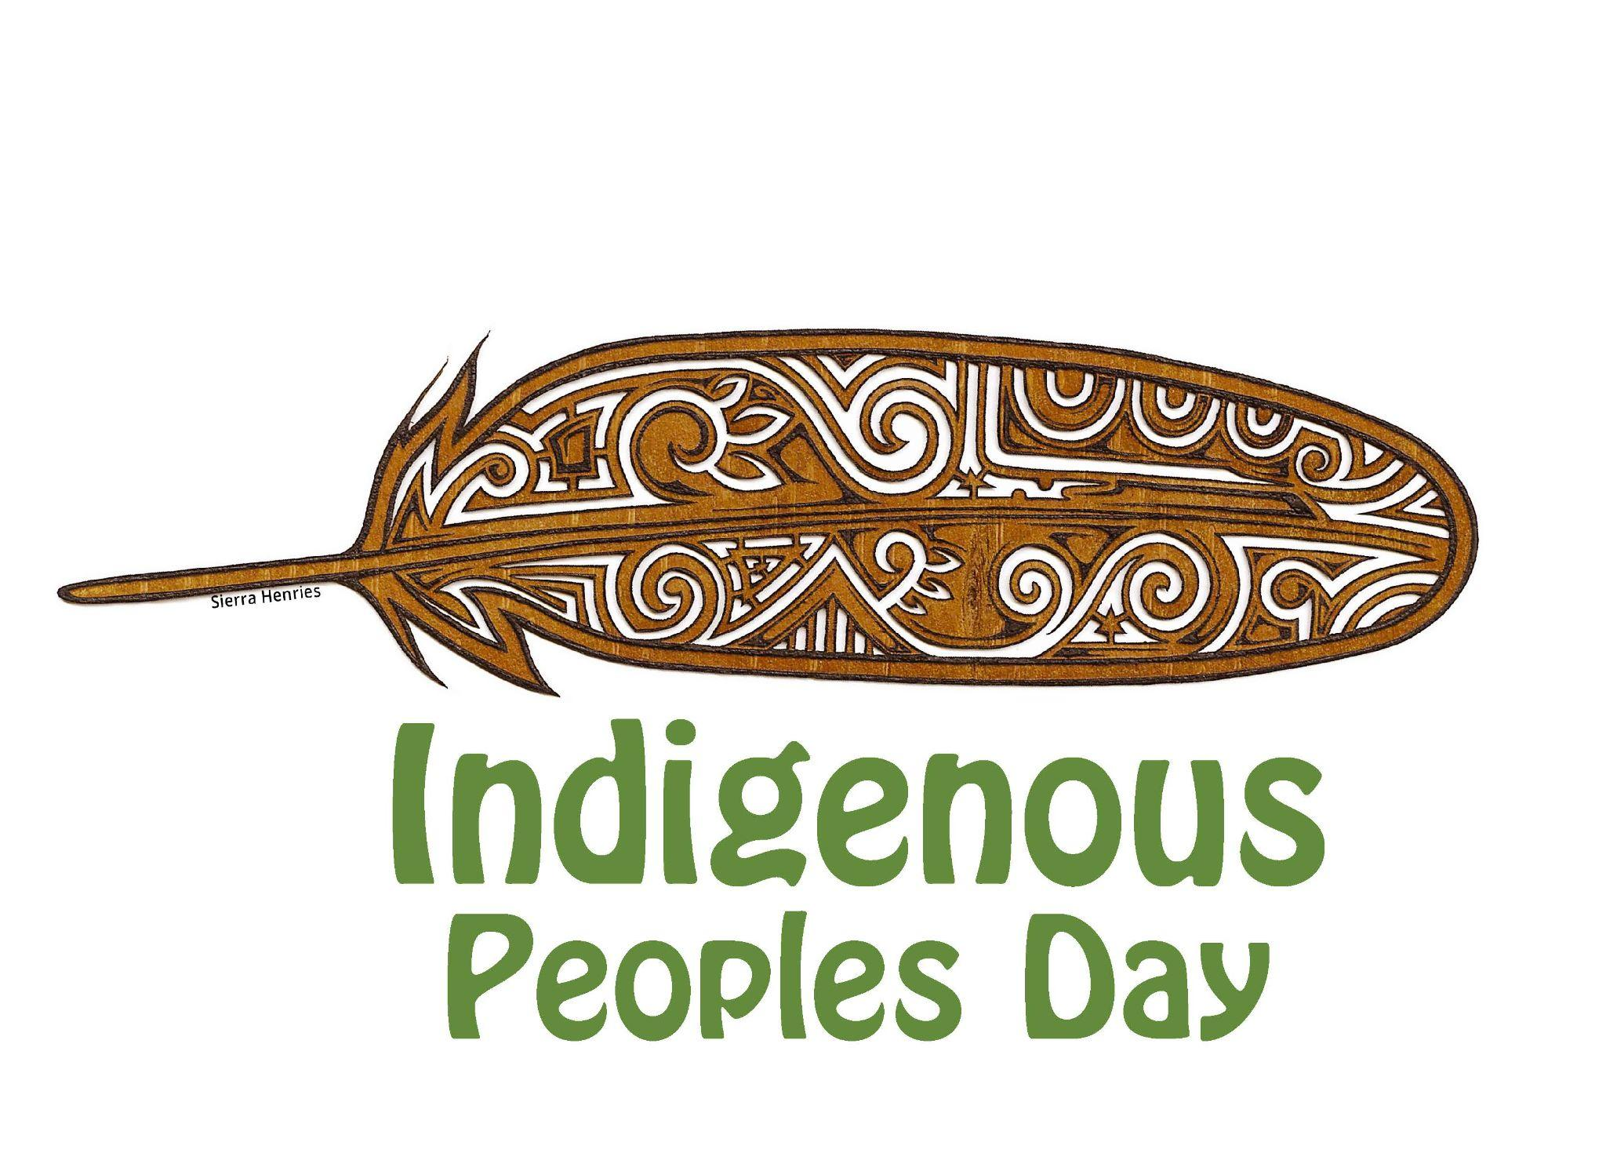
Newburyport 5th Annual Indigenous People’s Day Cultural Arts Event: Saturday October 11, 2025
Sponsorship Information

Join our initiative and free family friendly event to celebrate traditional and contemporary Indigenous cultural arts, knowledge and diversity, honoring our region’s Native communities and all Peoples. We welcome community participation, including Indigenous and allied partners, sponsors, volunteers, educators, students, and others to join us in support of this event which has become a touchstone in our community!

This event brings together Native and non Native individuals, businesses and groups to raise awareness for Indigenous People’s Day, and deepen our support for regional Indigenous arts and cultures! Together we partner to create community space for expanding cross-cultural connections, sharing and learning experiences. Attached is a preliminary poster with some of our community partner organizations.
As a volunteer run 501 C3 community nonprofit coalition we depend on community partners and business sponsors to make this free event possible! We are seeking tax deductible financial or in-kind donations of goods and services. These go directly toward honorariums to support Indigenous musicians, performers, educators, speakers, presenters, artists and youth activities. We are grateful for your support!
Event Highlights for Newburyport’s 5th Indigenous People’s Day!: Imagine Studios is honored and pleased to be a 2025 grant recipient of the NEFA "Public Art for Spatial Justice" grant for "The Merrimack Mishoon Project" with master mishoon dugout canoe makers Darius Coombs (Mashpee Wampanoag) and Jonathan Perry-Aquinnah Wampanoag Artist. Please consider supporting this exciting public mishoon making project, events, the maiden voyage on October 11th at Indigenous People’s Day!!

More Info: www.imaginestudios.org, FB or Instagram
Contact: kristine@imaginestudios.org or 978-834-0367.
Business and Community Sponsorship Opportunities

As a sponsor, your logo or name will be added to event posters, postcards, websites, email marketing, social media and other ways to acknowledge your support and promote your business or organization.
Sustainer: 1000
Logo on event poster, postcards, event signage and banners
Logo and link featured on event website and social media
Opportunity to provide brochures/literature at the event
Recognition during the event

Community Partner: 500
Logo on event poster, postcards, event signage
Logo and link featured on event website and social media
Opportunity to provide brochures/literature at the event
Recognition during the event

Business Sponsor: 250
Name on event poster, postcards, event signage
Name and link featured on event website and social media
Opportunity to provide brochures/literature at the event
Recognition during the event

Friend: 100
Name on event signage day of the event

For more information: kristine@imaginestudios.org 978-834-0367
www.imaginestudios.org

2025 Newburyport Indigenous People’s Day Sponsorship Form
Deadline: August, 2025

Name:__________________________________________________
Contact Email:____________________________________________
Contact Phone:____________________________________________
Business Name:___________________________________________
Address:_________________________________________________
Website:_________________________________________________
Facebook Page:___________________________________________
Instagram Handle:__________________________________________
Sponsorship Levels:
$_________ Sustainer
$_________ Community Partner
$_________ Business Sponsor
$ Friend
$ Raffle or In-Kind Donation
$__________Merrimack Mishoon Benefactor (Check if you want to contribute specifically to this project)
___________In-Kind Donation (Presenter housing, food, printing/marketing, volunteer etc.)

Please make checks payable to Imagine Studios or donate via PayPal or Venmo:@ImagineStudiosOrg
Email logos to: kristine@imaginestudios.org
Contact: 978-834-0367/ www.imaginestudios.org
Donate via PayPal or Venmo: @ImagineStudiosOrg

